2016 BICYCLE STORAGE PLAN
PROPOSED STANDARDS FOR DEVELOPMENTS OF SIGNIFICANT IMPACT located IN THE CITY OF MORGANTOWN, WV



This plan was made with assistance from the City of Morgantown City Council, Planning Commission, Traffic Commission, and Bicycle Board members.
Bicycle Board Review Draft
Presented on: April 7, 2016

City Council | Morgantown Planning Commission
Marti Shamberger, Mayor, Ward 5 | Peter DeMasters, Chair, Ward 6
Bill Kawecki, Deputy Mayor, Ward 2 | Carol Pyles, Vice President, Ward 7
Ron Bane, Ward 1 | Bill Kawecki, Council Representative
Wes Nugent, Ward 3 | Sam Loretta, Ward 1
Jennifer Selin, Ward 4 | Tim Starnko, Ward 2
Jay Redmond, Ward 6 | William Blosser, Ward 3
Nancy Ganz, Ward 7 | William Petros, Ward 4
 | Mike Shuman, Ward 5
 | Vacant, Administration Representative

Traffic Commission | Bicycle Board
Chris Gluck, Chair | Drew Gatlin, Chair
David McKain, Vice Chair | Chip Wamsley, Vice-Chair
William Blosser | Frank Gmeindl
Matthew Cross | Harry Grandon
Damien Davis | Christina Hunt
Martin Dombrowski | Traci Knabenshue
Julia Durham | Jonathan Nellis
Chris Fletcher | Marilyn Newcome
Drew Gatlin | Brian Ricketts
Robert Jones | Jonathan Rosenbaum
FSgt. Matt McCabe | Gunnar Shogren
Lisa Mardis | Derek Springston
Roy S. Nutter | Matt Watson
Jay Redmond | Jing Zhang
Paul Steel

Special Thanks to:
Jonathan Rosenbaum
Jonathan Nellis
Drew Gatlin
Chip Wamsley
Frank Gmeindl
and the City of Morgantown Development Services Department,
City Engineering Department, and City Attorney’s Office

Contents
Proposed Bicycle Parking Standards for Developments of Significant Impact 1
5% Target 1
Development of Significant Impact 1
Table 1: Development of Significant Impact 2
Image 1: DSI and Potential DSI Areas in the B-4 Zoning District 3
Image 2: DSI Areas in the City of Morgantown Excluding B-4 Zoned Parcels 4
Image 3: Potential DSI Areas in the City of Morgantown Excluding B-4 Zoned Parcels 5
How do the Proposed Bicycle Parking Standards Compare to Other Cities in the United States? 6
Table 2: Bicycle Parking Comparison 6
Design Standard for Bicycle Racks 7
Table 3: Bicycle Racks Comparison 7
Image 4: Unacceptable Short-Term Bicycle Parking Racks 7
Additional Design Standard for Long-Term Bicycle Rack 8
Zoning Ordinance Text Amendment 8
Zoning Ordinance Text Amendment Implementation Schedule 8
Current Edited Zoning Ordinance Text 8

Proposed Bicycle Parking Standards for Developments of Significant Impact
In keeping with the City of Morgantown’s 2013 Comprehensive Plan, the Morgantown Metropolitan Planning Organization Long Range Transportation Plan, and the 2012 Greater Morgantown Bicycle Plan, the Bicycle Board is seeking text amendments to Morgantown’s zoning ordinance to enable increased access to bicycle parking. The Bicycle Board is a committee of the Traffic Commission, and is tasked with making Morgantown, a bicycle friendly community, in addition to advising the City on bicycle related issues.

5% Target
The 2012 Greater Morgantown Bicycle Plan (2012 Plan) has the overall Goal of increasing bicycle use, while decreasing bicycle crashes. One objective in completing this goal is for bicyclists to be treated as equals to motorists in all activities. This 2012 Plan Goal also aims for bicycles to be used for 5% of all trips in and through Morgantown by 2020.
In keeping with the 2012 Plan’s use and safety goal, stated objective to this goal, and bicycle use target, the intent of these parking standards is to provide safe bicycle parking in all Developments of Significant Impact. Safe bicycle parking is achieved using existing automobile parking standards, and applying a 5% bicycle use to those standards. The result of the 5% target, is a spatial provision of bicycle parking in all Developments of Significant Impact.

Development of Significant Impact
The proposed standard will apply to higher impact, new development, defined by the City of Morgantown Planning and Zoning Code as Developments of Significant Impact (DSI). Developments of Significant Impact are defined per the code, as shown on Table 1: Development of Significant Impact, on Page 2.

Table 1: Development of Significant Impact
Land Use Category/District | Development of Significant Impact
Residential | A development that is 12 or more dwelling units
Non-Residential | A development that is either 15,000 square feet or more of gross floor area or a site of 2 acres or more of net acreage
Mixed-Use | A development that exceeds any of the following: 15,000 square feet or more of gross floor area of non-residential use(s); or, 12 or more dwelling units; or, 2 acres or more of net acreage
Industrial | All industrial development, regardless of gross floor area or net acreage of the site
Development in the B-4 District:
All Land Use Categories | New construction of a principal structure, regardless of land use category or net acreage of the site
Residential | A development that is 12 or more dwelling units
Non-Residential | A development that is either 10,000 square feet or more of gross floor area or a site of one-half (1/2) acre or more of net acreage
Mixed-use | A development that exceeds any of the following: 10,000 square feet or more of gross floor area of non-residential use(s); or, 12 or more dwelling units; or, one-half (1/2) acre or more of net acreage
Industrial | All industrial development, regardless of gross floor area or net acreage of the site

All new principal structures in the downtown core, developments with net acreages of two acres or more, all new industrial development, new housing subdivisions with 12 or more units, and all new non-residential development of 15,000 square feet or more (at the very least) will be required to install bicycle parking. Additional restrictions are placed onto development in the downtown area.
The following images highlight existing parcels currently within the corporate boundary of the City of Morgantown that do or have the potential to meet acreage thresholds identified by the Development of Significant Impact area thresholds. Image 1 provides information related to the B-4 zoning district, primarily in the area of the downtown. Images 2 and 3 provide Information for Developments of Significant Impact in areas outside of the B-4 Zoning District. Images 2 and 3 also highight the amount of area within the City of Morgantown that is zoned for residential uses. This data does not include newer development in the most southern portion of the City of Morgantown (Walmart and associated pad-sites).

Image 1: DSI and Potential DSI Areas in the B-4 Zoning District

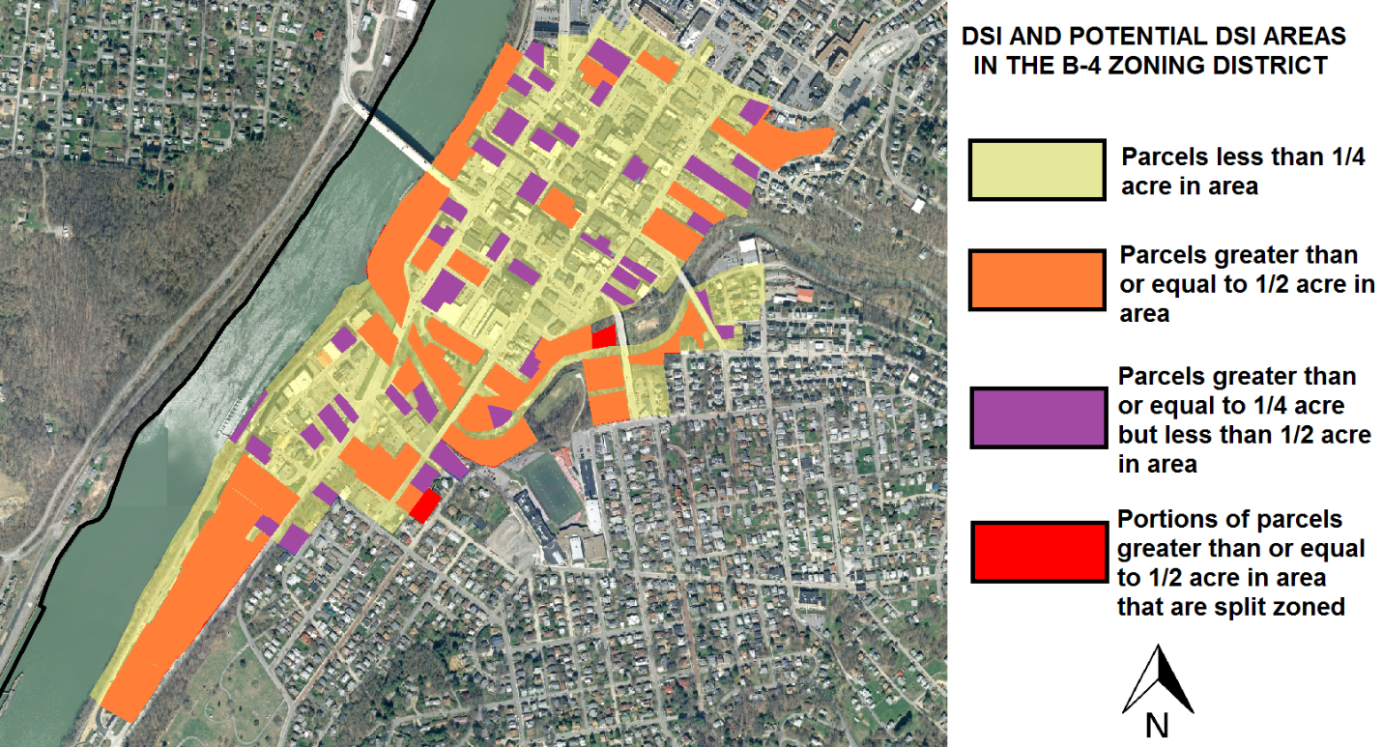

As shown in Image 1, parcels identified with the color orange and red, would be affected by the bicycle storage requirement. In addition to orange parcels, all new principal buildings on any parcel in the B-4 zone would also be affected.

Image 2: DSI Areas in the City of Morgantown Excluding B-4 Zoned Parcels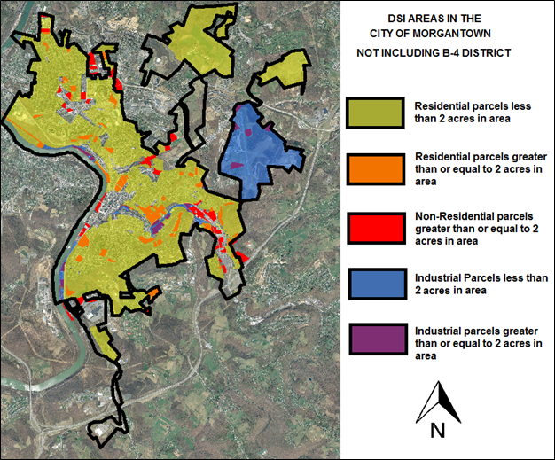

As shown in Image 2, parcels identified with the colors red, blue, and purple would be affected by the bicycle storage requirement. In addition, new development on parcels identified with the color orange may be required to conform to bicycle storage requirements if a mixed-use development is provided on site.

Image 3: Potential DSI Areas in the City of Morgantown Excluding B-4 Zoned Parcels 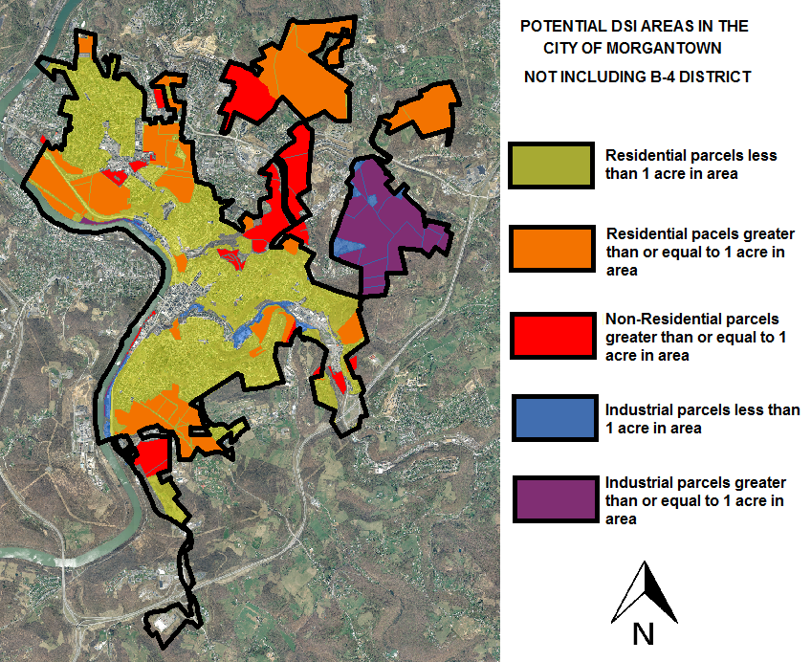

As shown in Image 3, parcels identified with the colors red, blue, and purple could be affected by the bicycle storage requirement, if combined with adjoining parcels. In addition, new development on parcels identified with the color orange may be required to conform to bicycle storage requirements if consolidation of parcels is utilized for a mixed-use development.
In addition to identifying acreage area thresholds for Developments of Significant Impact, gross floor area is also important to conceptualize. A building in the downtown area that includes a non-residential use that has a gross floor area of 10,000 square feet would be affected by the bicycle storage requirement. A floor area of 10,000 square feet can be conceptualized as a one story square building that is 100 feet by 100 feet square, a four-story rectangular building that is 20 feet by 125 feet per floor, or any number of other building footprint configurations. It is important to remember that while these non-residential uses may not currently be planned for the downtown, other cities in the United States have experienced neo-urban infill development in their downtown cores in the form of mixed-use apartment, office, and commercial buildings or building clusters, such as the Google’s Bakery Square development in Pittsburgh and Charleston West Virginia’s Urban Renewal Authority activities.
For areas outside of the B-4 Zoning District, non-residential development with a gross floor area of 15,000 square feet or more, is also regulated by the Development of Significant Impact. Smaller retailers on individual parcels would not have to comply with the bicycle storage requirements, alleviating a potential impediment to small business entrepreneurship. Bicycle parking opportunities and improvements for smaller businesses should be encouraged by the City of Morgantown and civic institutions.
Examples of national retailers and nonresidential uses that routinely have stores that are 15,000 square feet or more in gross floor area include supermarkets, pharmacies, private recreational facilities, and combined doctors’ offices. In addition to those consumer uses, mixed-use town centers and office parks are also found to have gross square footage that would require a Development of Significant Impact designation.
Finally, residential housing developments with twelve or more units would require a Development of Significant Impact review. As permitted by the zoning ordinance and permissible under existing spatial constraints, a residential housing development outside of the B-4 zone would generally not be physically possible within the current city boundary. In the R-1 Zoning District, individual single family houses are required to be on parcels that are greater than or equal to 7,200 square feet in area. Twelve housing units in the R-1 zone would thus require 1.98 acres of developable land, just for the housing sites. In the R-1A Zoning District, parcels are required to be greater than 3,500 square feet in area. Twelve housing units in the R-1A zone would thus require 0.96 acres of developable land, just for the housing sites. Additional land uses including right-of-way and open space increase area requirements, while the topography of developable land further increases needed land for a DSI residential development. Instead, new residential development in the vein of the Development of Significant Impact will most likely be created using Planned Unit Development or will require annexation or some other Planning Commission approval.

How do the Proposed Bicycle Parking Standards Compare to Other Cities in the United States?
The Proposed Bicycle Parking Standards are similar to other active cycling communities’ parking standards. The proposed standards out-perform many jurisdictions, but also provide additional room for future modification. The following table compares the Proposed Bicycle Parking Standards for Developments of Significant Impact, with other jurisdictions’ bicycle parking standards.

Table 2: Bicycle Parking Comparison
 | Cities
 | Cambridge, MA | Portland, OR | Boulder, CO | Pittsburgh, PA | Burlington, VT
Long-Term Residential Parking | More | Fewer than | Fewer than | More | More
Short-Term Residential Parking | More | Fewer than | Fewer than | More | Fewer than
Long-Term Retail Parking | More | Similar | Fewer than | More | More
Short-Term Retail Parking | Fewer than | More | Fewer than | More | More
Long-Term Office Parking | More | More | Fewer than | More | Similar
Short-Term Office Parking | Fewer than | More | Fewer than | More | More
Long-Term Restaurant Parking | More | More | More | More | More
Short-Term Restaurant Parking | Fewer than | More | Fewer than | More | Fewer than

Design Standard for Bicycle Racks
The City of Cambridge, MA 2013 Bicycle Parking Guide provides a detailed analysis of acceptable and unacceptable Short-Term bicycle Parking Racks. The following guide highlights characteristics for racks of both short-term and long-term types, based on Cambridge’s 2013 Bicycle Parking Guide.

Table 3: Bicycle Racks Comparison
Acceptable Bicycle Racks | Unacceptable Bicycle Racks
- Area is installed on a permanent foundation (e.g., concrete pad) to ensure stability;  - Securely anchored into or on the foundation with tamper-proof nuts if surface mounted;  - Provides support for an upright bicycle by its frame horizontally in two (2) or more places;  - Keeps both bike wheels on the ground;  - Is designed to prevent the bicycle from tipping over;  - Is able to support a variety of bicycle sizes and frame shapes;  - Provides space to secure the frame and one or both wheels to the rack with a cable, chain, or u-lock;  - Has a locking pole with a diameter of no more than 1.5 inches. | - Support the bicycle at only one point;  - Allow the bicycle to fall, which can damage the bike and block pedestrian right-of-way;  - Have sharp edges, that can be hazardous to the visually impaired;  - Support the bicycle by one wheel;  - Connect to each other with a bar on top (that can block handlebars and baskets);  - Suspend any part of the bike in the air or require that the bicycle be lifted to get it into position.

The following image from the City of Cambridge, MA 2013 Bicycle Parking Guide, shows examples of unacceptable Short-Term Bicycle Parking Racks:

Image 4: Unacceptable Short-Term Bicycle Parking Racks
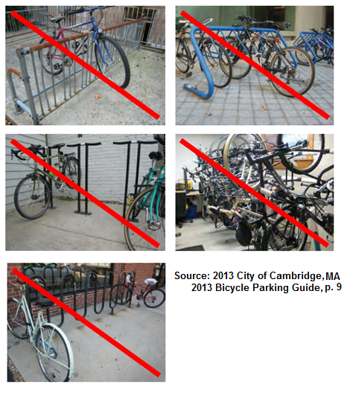
The Proposed Bicycle Parking Standards for the City of Morgantown incorporate design characteristics for bicycle racks, by using Table 3: Bicycle Racks Comparison, as the basis for bicycle parking ordinance text. Additional language specifies one (1) bicycle parking space, as three feet in width, by six feet in length, and four feet tall (3’x6’x4’), at a minimum, and provides for safety and ADA compliance aspects for rack design. A developer would be permitted to construct a bicycle rack that meets these acceptable bicycle rack design standards, as they see fit, and potentially in a creative manner for the specific development site.

Additional Design Standard for Long-Term Bicycle Rack
Long-Term bicycle parking is required to be indoor, secured, and sheltered (e.g. a room with walls, a roof, and a door that can shut). Spaces are counted based on physical volume, at a standard of one (1) bicycle parking space, as three feet in width, by six feet in length, and four feet tall (3’x6’x4’), at a minimum. Additionally, each space must permit the bicycle to be secured with a lock to a permanent structure. How this standard is achieved is at the purview of the developer. Long-Term Bicycle Parking can be located in the primary structure or as an accessory structure (e.g. shed) within a reasonable distance to the primary structure’s entrance. Indoor long-term bicycle parking could be accomplished in a closet of a building, assuming spatial requirements are met and is functioning. A door opening into the room will negate the space of a bicycle parking space and would have to be accounted for, by the developer.

Zoning Ordinance Text Amendment
The Proposed Bicycle Parking Standards will be achieved by amending the Zoning Ordinance. A text amendment to the ordinance will require recommendation by the Bicycle Board to the Traffic Commission, recommendation by the Traffic Commission to the Planning Commission, recommendation by the Planning Commission to the City Council, and City Council Action.

Zoning Ordinance Text Amendment Implementation Schedule
Item | Hearing/Information Date
Bicycle Board Draft Amendments | Thursday, April 07, 2016
Traffic Commission Draft Amendments | Wednesday, May 04, 2016
Planning Commission Draft Amendments | Thursday, May 12, 2016
City Council Review | Tuesday, May 24, 2016
City Council Ordinance 1st Reading | Tuesday, June 07, 2016
City Council Ordinance 2nd Reading | Tuesday, July 05, 2016

Current Edited Zoning Ordinance Text
The following text amendments to Article 1365 Parking, Loading and Internal Roadways, subsection .04 Determining the Number of Spaces Required, starting on Page 9, are proposed to implement this plan.

1365.04 (Q) Bicycle Storage – Long-Term Bicycle Storage and Short-Term Bicycle Storage shall be provided in all Developments of Significant Impact.
(1) For all Developments of Significant Impact, the minimum Long-Term Bicycle Storage amenities described in this Subsection must be provided. The minimum Long-Term Bicycle Storage amenities are as follows:
(a) One (1) Long-Term bicycle storage space per occupant.
(b) One (1) Long-Term bicycle storage space for every 20 parking spaces as required in accordance with Table 1365.04.01: Minimum Off-Street Parking Requirements.
(c) Long-term bicycle parking is required to be covered and shall include use of one of the following:
(i) A locked room;
(ii) An area enclosed by a fence with a locked gate;
(iii) An area within view of an attendant or security guard or monitored by a security camera; or
(iv) An area visible from employee work areas.
(d) The bicycle parking area should be located within fifty (50) feet of the primary entrance of the building it serves and at a minimum shall be located on site or in an area within three hundred (300) feet of the entrance of the building it serves; and in a location that can be reached by an accessible route.
(e) Adequate lighting shall be provided for the bicycle parking area and the route to the building entrance.
(f) The bicycle parking area shall include adequate clearance around racks or lockers to give cyclists room to maneuver, and to prevent conflicts with pedestrians or parked cars.
(g) If the bicycle parking is provided in an auto parking garage, the bicycle parking spaces shall be clearly marked as such and shall be separated from auto parking.
(h) Each space shall be a minimum of 3-feet in width, 6-feet in length and 4-feet in height.
(i) Long-term bicycle Storage Space designs must adhere to the design standards in section 1365.04(Q)(3), Bicycle Rack Requirements.
(2) For all Developments of Significant Impact, the minimum Short-Term Bicycle Storage amenities described in this Subsection must be provided. The minimum Short-Term Bicycle Storage amenities are as follows:
(a) One (1) Short-Term Bicycle Storage space for every 20 parking spaces as required in accordance with Table 1365.04.01: Minimum Off-Street Parking Requirements.
(b) Each Short-Term Bicycle Storage space shall be located:
(i) Outside a building;
(ii) within fifty feet of the main building entrances; and
(iii) at the same grade as the sidewalk or at a location that can be reached by an accessible route.
(c) The bicycle parking area shall include adequate clearance around racks or lockers to give cyclists room to maneuver, and to prevent conflicts with pedestrians or parked cars.
(d) Each space shall be a minimum of 3-feet in width, 6-feet in length and 4-feet in height.
(e) Short-term bicycle storage space designs must adhere to the design standards in 1365.04(Q)(3): Bicycle Rack Requirements.
(f) Short-term bicycle storage spaces should be placed under roof to encourage cycling and bicycle rack use.
(g) Short-Term Bicycle Storage shall consist of a physical improvement that is installed on a permanent foundation (e.g., concrete pad) to ensure stability; is securely anchored into or on the foundation with tamper-proof nuts if surface mounted; provides support for an upright bicycle by its frame horizontally in two (2) or more places; keeps both bike wheels on the ground; is designed to prevent the bicycle from tipping over; is able to support a variety of bicycle sizes and frame shapes; provides space to secure the frame and one or both wheels to the rack with a cable, chain, or u-lock; and has a locking pole with a diameter of no more than 1.5 inches.
(3). Bicycle Rack Requirements. Long-term and Short-term bicycle storage spaces shall use bicycle racks with the following design standards:
(a) Racks shall conform to Americans with Disabilities Act (ADA) standards for protrusions in the right-of-way including the ability to detect the rack with a white cane. To be detected by a white cane the protruding or leading edge of the rack shall be 27" or less above the sidewalk surface. Between 27" and 80" above the sidewalk surface, protruding or leading edges may overhang a maximum of 12".
(b) The top of the bicycle rack design shall be a minimum of 36" tall. Except for the bicycle rack supporting brackets, the shortest section of the bicycle rack must be a minimum of 27" tall - enough to be perceived by pedestrians and avoid tripping hazards.
(c) The space between rack features shall be larger than 9" and smaller than 3.5" to avoid children trapping their heads.
(d) The design shall not include sharp edges.
(e) Areas having more than one row of racks shall be separated by aisles. An aisle is measured from tip to tip of the bicycle spaces between racks. The minimum separation between aisles should be at a minimum 48" or conform to sidewalk width requirements of the underlying zoning district.
(f) Racks near walls should be placed so that the rack’s two bicycle connection points are perpendicular to such wall and should not be placed near property corners. Racks placed near walls shall maintain a minimum separation between the edge of the bicycle parking space at a minimum of 48" or conform to sidewalk width requirements of the underlying zoning district.
(g) Racks placed near curbs shall maintain a minimum separation between the edge of the parking space at a minimum of 48" or conform to sidewalk width requirements of the underlying zoning district.
(h) Racks should allow either front-in parking (U-lock should be able to lock the front wheel and the down tube of an upright bicycle) or back in parking (U-lock should be able to lock the rear wheel and seat tube of the bicycle).
(i) Racks should have protective coatings designed to protect bicycle frames from scratching and damage.
(j) Racks should be able to resist being cut or detached using common hand tools, such as bolt cutters, pipe cutters, wrenches, and pry bars.
NOTE #1: Additional text amendments to Article 1349.08(c) Parking, Loading and Internal Roadways, will also be included for amendment. These text amendments are as follows in the yellow highlighted sections:
1365.01 PURPOSE.
The regulations of this section are designed to alleviate or prevent congestion of the public streets by establishing minimum requirements for on-site storage of motor vehicles and bicycles, in accordance with the use for which the property is occupied.
1365.02 SCOPE.
(A) Off-street parking and loading facilities shall be provided and maintained in accordance with the provisions of this section for all buildings, structures or premises used in whole or in part for purposes permitted by this Code.
(B) When the intensity of use of any building, structure or premises shall be increased through the addition of dwelling units, floor area, beds, seating capacity, or other unit of measurement, parking and loading facilities as required herein shall be provided for such increase in intensity of use.
(C) For any non-conforming use which is hereafter damaged or partially destroyed, and which is lawfully reconstructed, re-established, or repaired, off-street parking and loading facilities equivalent to those maintained at the time of such damage or partial destruction shall be restored and continued in operation; provided, however, in no case shall it be necessary to restore or maintain parking or loading facilities in excess of those required by this Code for equivalent new uses.
(D) No building permit shall be issued, no use shall be established or changed, and no structure shall be erected, enlarged or reconstructed unless the applicant has presented satisfactory evidence via parking lot by an appropriate design or plan, that the required off-street parking and loading spaces herein are provided in the minimum amounts and maintained in the manner specified; provided, however:
(1) For the enlargement of a structure or for the expansion of a use of structure or land there shall be required only the number of additional off-street parking and loading spaces as would be required if such enlargement or expansion were a separate new structure or use; and
(2) For a change in the class or use of a structure or land, the number of additional off-street parking and loading spaces required shall be equal to the number required for the new use, less the number of spaces which would have been required for the previous use if it had been established in conformance with this section; but in no case shall the total number of spaces furnished be required to exceed the minimum required for the new use.
(E) Off-street parking or loading facilities in existence at the time of the effective date of this article shall not hereafter be reduced below, or if already less than, shall not be further reduced below, the requirements for a similar new use under the provisions of this Code.
(F) Nothing in this Code shall be deemed to prevent the voluntary establishment of off-street parking or loading facilities to serve any existing use of land or buildings, provided that all regulations herein governing the location, design, and operation of such facilities are met adhered to.
(G) Off-street parking and loading facilities provided to comply with the provisions of this Code shall not subsequently be reduced below the requirements of this Code.
1365.03 GENERAL PARKING REGULATIONS.
(A) Off-street parking and loading spaces shall be provided on the same lot as the use served, except as otherwise provided in this Code, and may be situated as one or more individual areas.
(B) Off-street parking facilities required herein shall be utilized solely for the parking of passenger automobiles or light trucks with not more than two axles, vehicles and bicycles belonging to patrons, occupants or employees of specified uses. Said The parking facilities shall not be used for (i) commercial vehicles or bicycles, including but not limited to motor vehicles with more than two axles, buses, construction equipment or vehicles, and commercial delivery vehicles; or (ii) the storage, display, sale, repair, dismantling or wrecking of any vehicle, equipment or material, unless such facilities are enclosed in a building and otherwise permitted in the district, and unless such display is conducted upon stalls that are otherwise considered surplus to the requirements herein.
NOTE #2: Additional text amendments to Article 1365 Parking and Loading Standards, Bicycle Storage for the B-4 General Business District zone will also be stricken from the Planning and Zoning Code and (D) Loading, renumbered to section (C). These text amendments are as follows in the yellow highlighted sections:
(C) Bicycle Storage – For all Developments of Significant Impact in this district, the following minimum bicycle storage amenities must be provided:
(1) One (1) indoor, secured, sheltered bicycle storage space per dwelling unit.
(2) Each space shall be a minimum of 3-feet X 6-feet X 4 feet.
(3) Each bicycle shall be individually secured with a lock to a permanent structure.
(4) There should be sufficient space for easy access to each bicycle.
(D C) Loading – Residential uses containing thirty (30) or more dwelling units shall
conform to the loading requirements set forth in Section 1365.10 as a “Type II Use” (see Table
1365.10.01). (Ord. 15-34. Passed 6-2-15.)

